Profit news

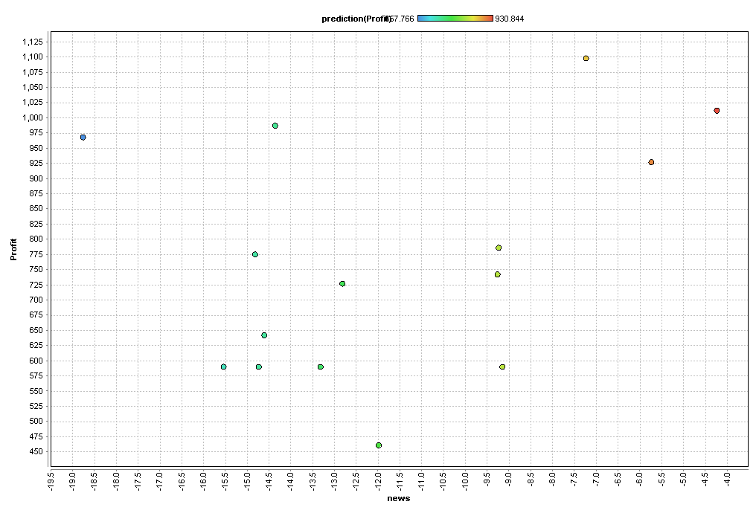

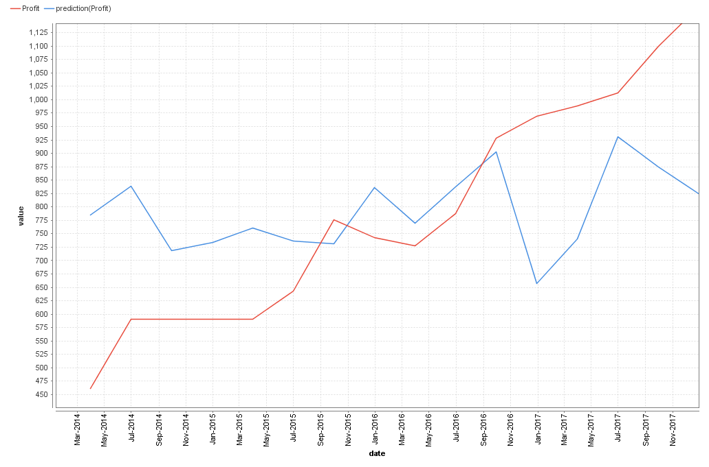

Profit trend

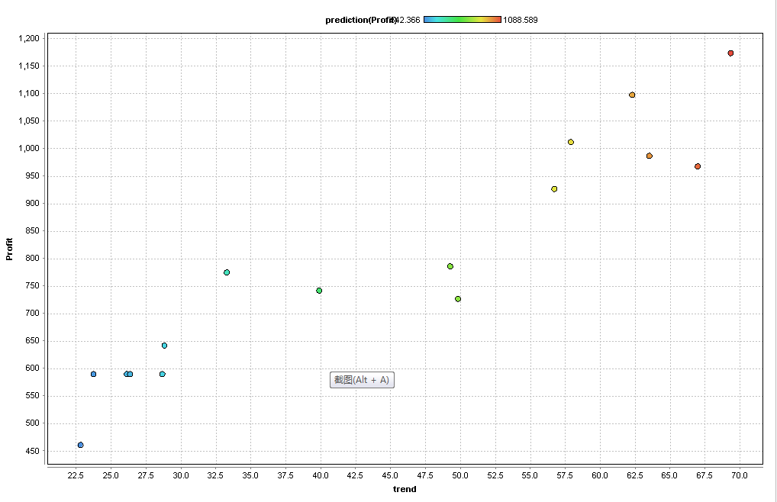

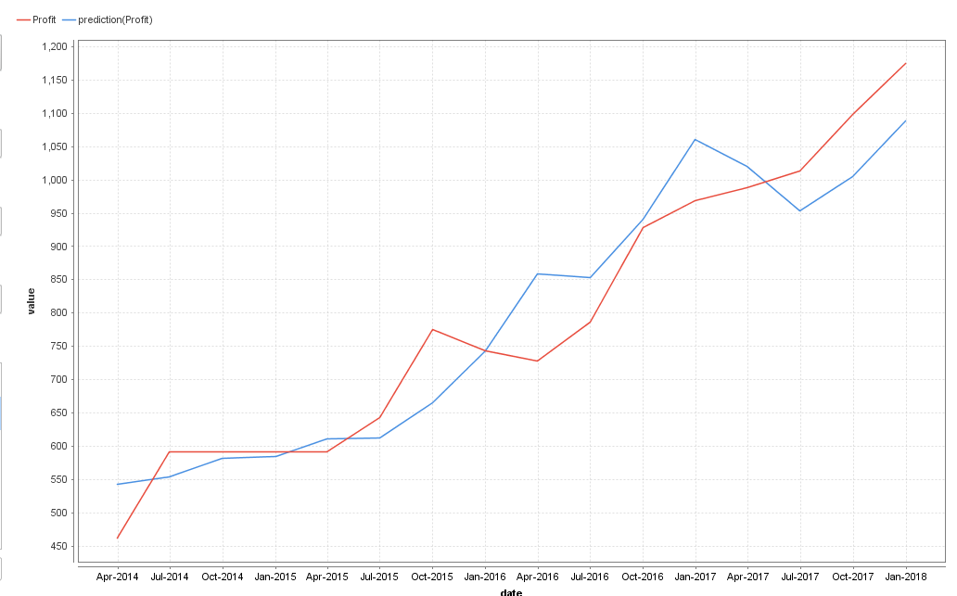

Profit stock

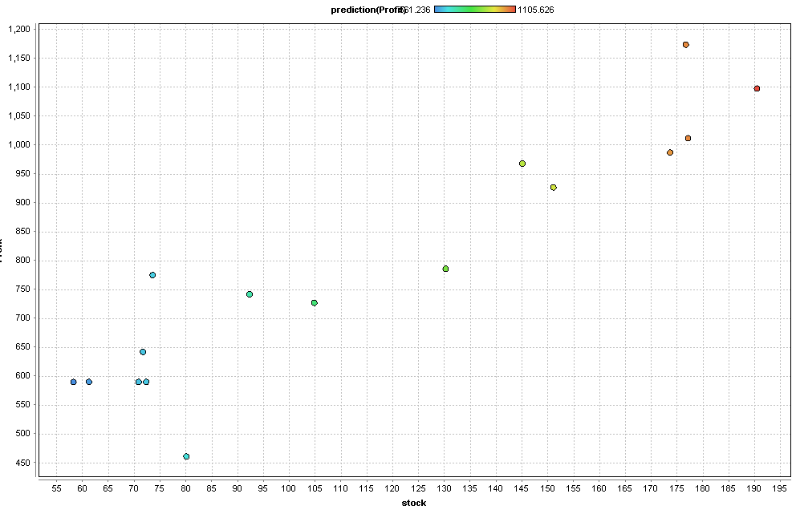

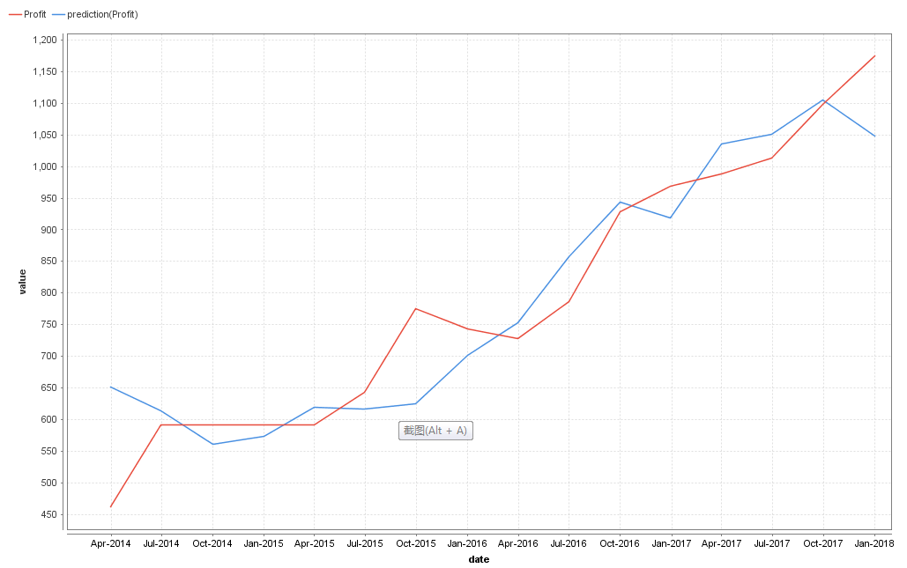

Profit comment

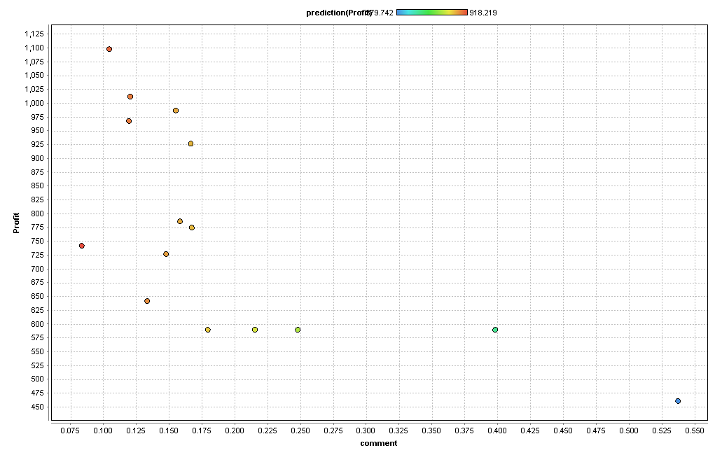

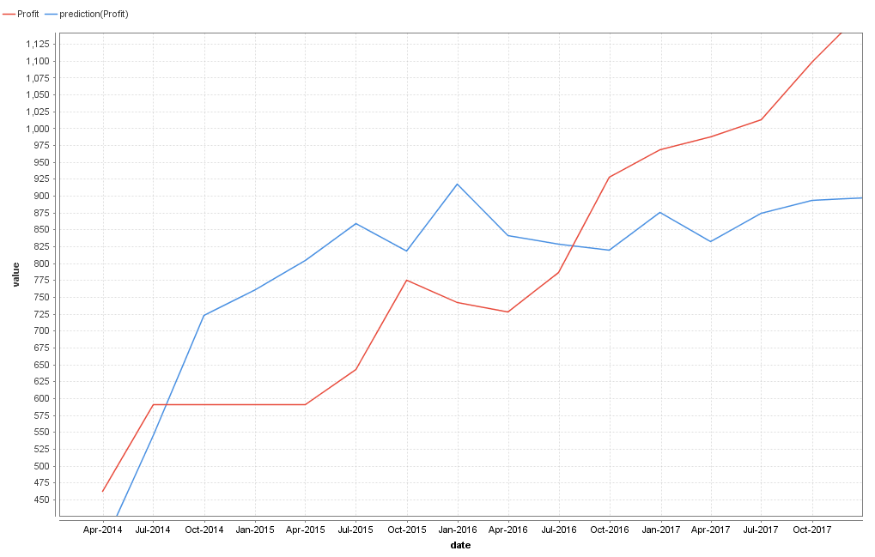

Profit rating

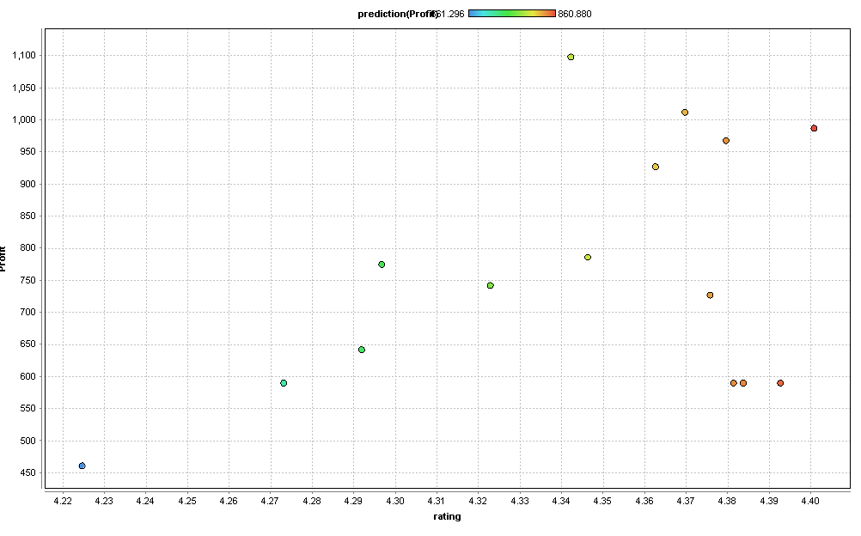

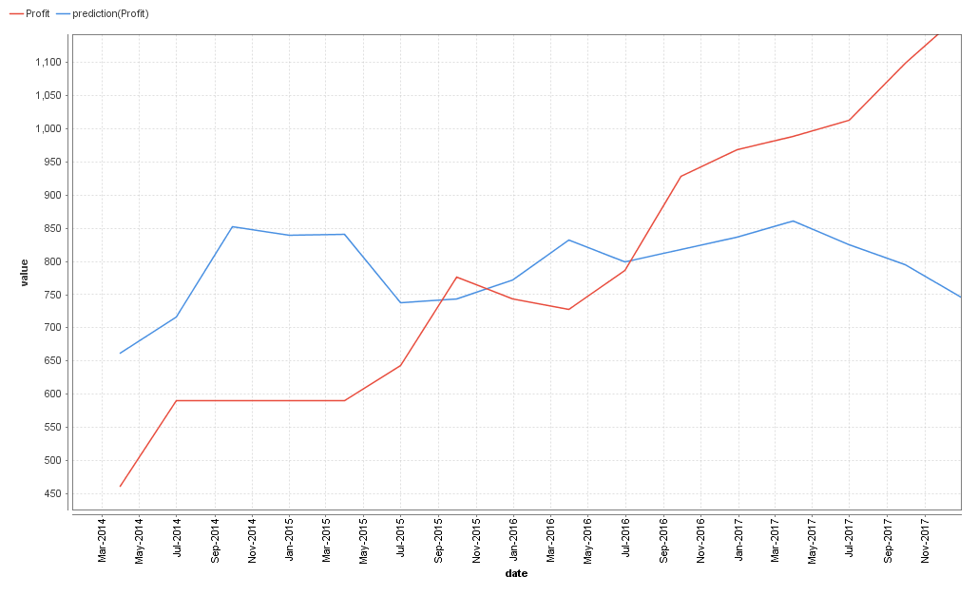

|  |  |  |  |  |
| --- | --- | --- | --- | --- |
| x | y | Coefficiency | P-value | IMG_256 |
| rating | profit | 1132.839 | 0.312 | 0.073 |
| comment | profit | -1186.196 | 0.005 | 0.442 |
| trend | profit | 11.743 | 0 | 0.893 |
| stock | profit | 4.117 | 0 | 0.864 |
| News | Profit | 18.797 | 0.183 | 0.123 |